a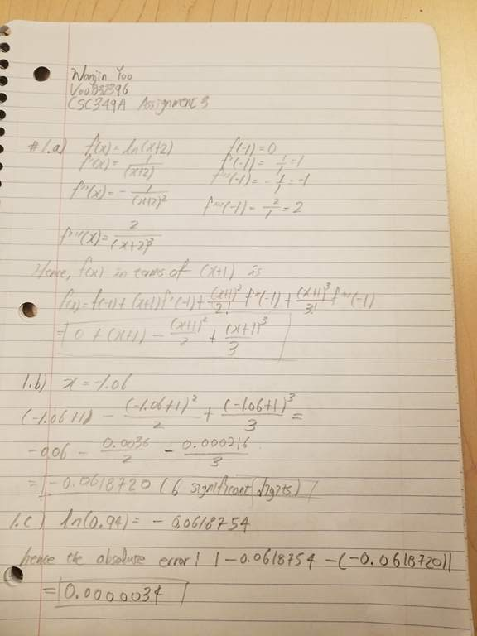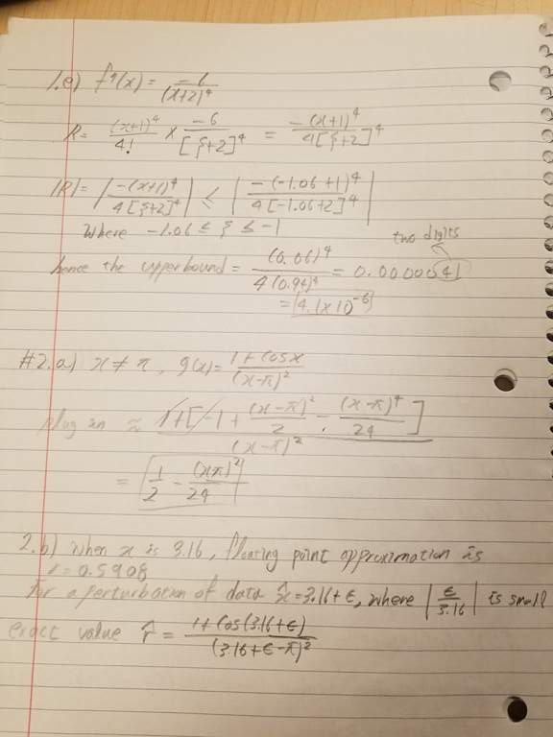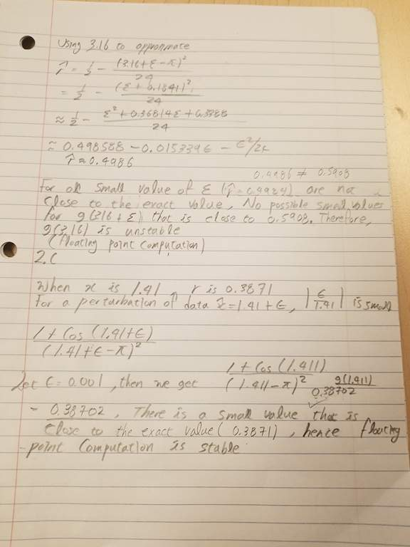

3.a)

function root = Bisect ( x1 , xu , eps , imax, f )

fl= f(x1);

i = 1;

fprintf ( " iteration approximation \n")

while i <= imax

xr = (x1+xu)/2;

fprintf ( " %6.0f %18.8f \n", i, xr );

fr = f(xr);

if (xu-x1)/abs(xu+x1) <eps || fl ==0

root = xr;

return

end

i= i+1;

if fl\*fr <0

xu =xr;

else

x1=xr;

fl=fr;

end

end

fprintf ( " failed to converge in %g iterations\n", imax);

3.b)

function y = f(x)

y = pi \* x^2 \* (3\*4.1 - x)/3 -45;

Bisect(0,4.1,1e-4,20,@f);

iteration approximation

1 2.05000000

2 1.02500000

3 1.53750000

4 1.79375000

5 1.92187500

6 1.98593750

7 2.01796875

8 2.03398437

9 2.04199219

10 2.04599609

11 2.04799805

12 2.04699707

13 2.04749756

14 2.04724731

15 2.04737244

3.c)

function y = f(x)

y = 9.81 \*x / 13.5 \* (1-exp(-13.5\*10/x)) – 40

Bisect(1,100,1e-4,20,@f);

iteration approximation

1 50.50000000

2 75.25000000

3 62.87500000

4 56.68750000

5 59.78125000

6 61.32812500

7 62.10156250

8 62.48828125

9 62.29492188

10 62.19824219

11 62.14990234

12 62.12573242

13 62.11364746

14 62.10760498